Kindo registration link

Our online Kindo school shop links to our school records, and we’ve noticed that you have students that are not yet linked.
This could be because:
- you have not yet set up your myKindo account
OR
- you have a myKindo account already, but are using a different email address to log in, than the one the school has on file for you.

Don’t yet have a myKindo account?
You can easily register – it only takes a couple of minutes!
- Click here to register
- Enter in the email address the school has on file for you.
- Check your inbox for an email from Kindo with a link to set-up your password.

Your myKindo account is now set-up!

Already have a myKindo or ezlunch account?
Log in to your account and click on the ‘Fees and Donations’ service. If you see a message similar to this one, you need to link your student:

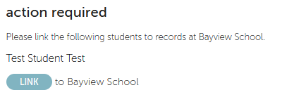

If you need to update your email address, you can either change your login email on Kindo to match the school email address using the ‘my details’ page,
OR
give the school a call and update your school email address to match your myKindo login one.

(NOTE: school updates happen every hour for the transfer over to Kindo, so please allow at least one hour before checking again).

Once your myKindo account is set-up and your students linked, you will be able to:
- see any outstanding payments on your personalised family account.
- choose to make a part payment or full payment.
- and we’ll amend your child’s class automatically when our school records are updated.

Need assistance? Our Kindo helpdesk is open 8am to 4pm weekdays.
Freephone: 0508 4 KINDO (0508 454 636) Email: hello@mykindo.co.nz
Online support: support.mykindo.co.nz

